Valentine pre order closes February 11th 12pm

Bunches Valentines Vase Arrangement $60
Options for pick up
Feb. 13th

10am -12 am

4pm - 6:30 pm
Feb. 14th
10am - 12am
4pm - 6:30pm
Delivery extra Elmvale surrounding area $8
Description: A gorgeous design of local Ontario greenhouse grown blooms for your special someone!
There is no better way to say I love you or appreciate you, than with Niagara greenhouse grown flowers that are in season right now. Flowers in your arrangements will include super fragrant long lasting, Tulips, Freesias, Mums, Lisianthus and Lilies and greenery!
Disclaimer; this is an example of the arrangement; please not colour palette and flowers choice may slightly vary!

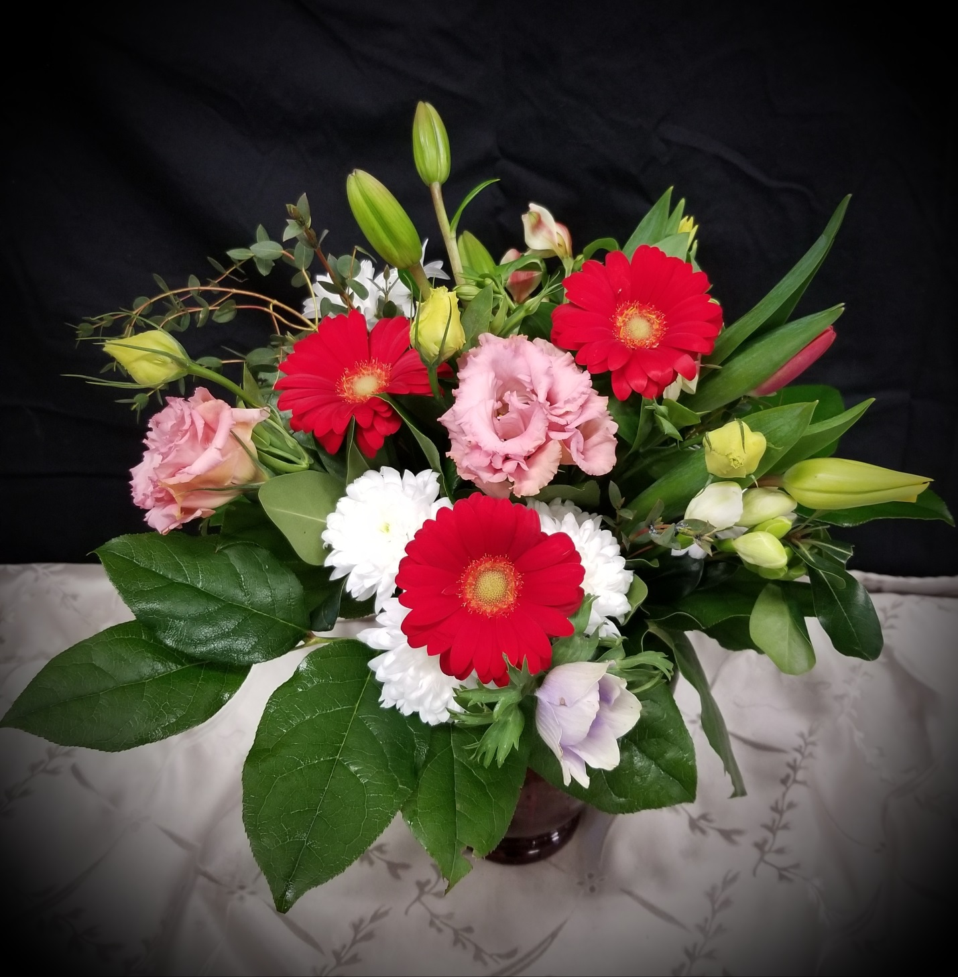

Bunches Handtied Bouquet wrapped in Kraft paper $50

Options for pick up
Feb. 13th
10am -12 am
4pm - 6:30 pm
Pick up Feb. 14th
10am - 12am
4pm - 6:30pm
Delivery extra Elmvale surrounding area $8
Description: A gorgeous design of local Ontario greenhouse grown blooms for your special someone!
There is no better way to say I love you or appreciate you, than with Niagara greenhouse grown flowers that are in season right now. Flowers in your arrangements will include super fragrant Lilies, Tulips, Freesias, Mums, Lisianthus and greenery!
Disclaimer; this is an example of the arrangement; please not colour palette and flowers choice may slightly diver.

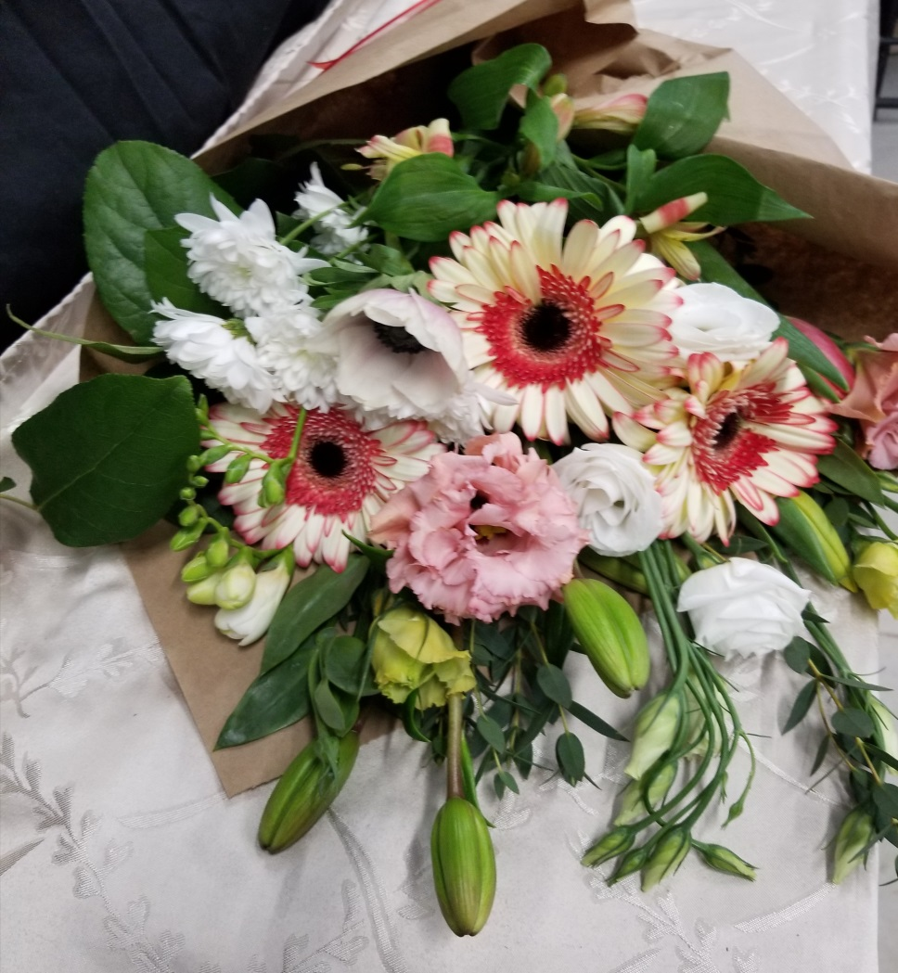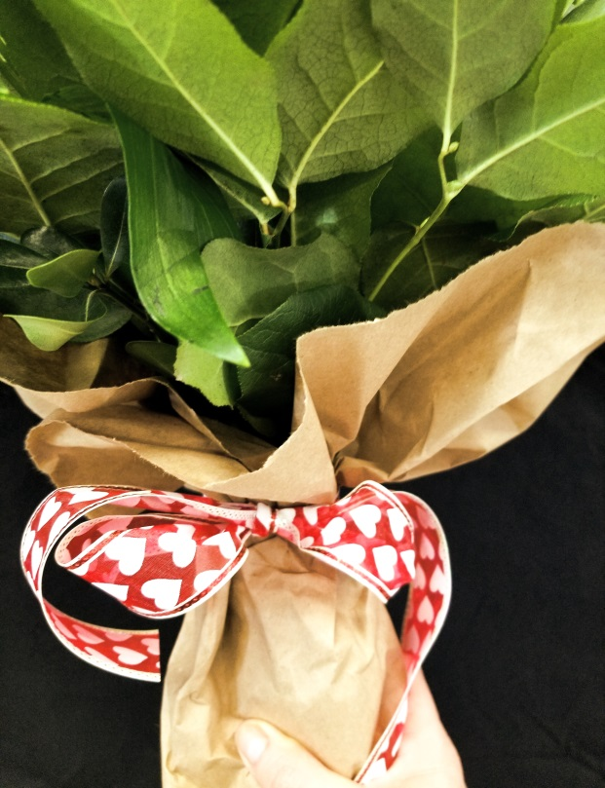

Large Mixed Bouquet of Premium Tulips and Ranunculus $65

Pick up options

Pick up Feb. 13th
4pm - 6:30 pm

Pick up Feb. 14th
10am - 12am
4pm - 6:30pm
Delivery extra: Elmvale surrounding area $8
Description: A mixed Bouquet of premium Ontario grown Tulips and Ranunculus handtied, wrapped in Kraft paper tied with ribbon.
Ranunculus is considered a favorite flower by many and very dainty and soft flower!
There is no better way to say I love you or appreciate you, than with Niagara greenhouse grown flowers that are in season right now.
Disclaimer; this is an example of the arrangement; please not colour palette may slightly diver.
